# SINGLE AND MULTI-OBJECTIVE OPTIMIZATION FOR REAL WORLD PROBLEMS

A Project report submitted in partial fulfilment of the requirements for the award of the degree of

BACHELOR OF TECHNOLOGY IN

ELECTRONICS AND COMMUNICATION ENGINEERING

**Submitted by :**

D Hafeez - BU21EECE0100213

V Varun Sai – BU21EECE0100108

U Pavani – BU21EECE0100474

## Under the guidance of

DR. Avishek Chakraborthy, DEPT OF EECE



GANDHI INSTITUTE OF TECHNOLOGY AND

MANAGEMENT

(Deemed to be university)Bengaluru Campus.

NH 207,Nagadenahalli, Doddaballapur Taluk,Bengalur-561203

Karnataka, India

# DECLARATION

I/We declare that the project phase-1 work contained in this report is original and it has been done by me under the guidance of my project guide.

**Signature of the student Date:-**

## Name:-

D Hafeez - BU21EECE0100213

V Varun Sai – BU21EECE0100108

U Pavani – BU21EECE0100474

**Department of Electronics and Communication Engineering**

**GITAM School of Technology and Management,Banglore-561203**



**CERTIFICATE**

This is to certify that D Hafeez , V Varun Sai, U Pavani bearing

RegNo:BU21EECE0100213,BU21EECE0100108,BU21EEC

E0100474 has satisfactorily completed project phase 1 Entitled in partial fulfilment of the requirements as prescribed by the university for the VIII semester, Bachelor of Technology in

“Electronics and Communication Engineering” and submitted this report during the academic year 2024-2025.

Signature of the guide Signature of

HOD

------------------- ---------------------

# ACKNOWLEDGEMENT

The Satisfaction and Euphoria accompanying the successful completion of any Major Project would be incomplete without mentioning the people who made it possible, and whose constant guidance and encouragement crowned our efforts with success. We take this opportunity to express the deepest gratitude and appreciation to all those who held us directly or indirectly towards the successful completion of the Project. We would like to thank HOD **Dr Pridhvi Sekhar Pagala** for his support and encouragement which went a long way in the successful completion of this Major Project. We consider that a privilege to express our gratitude and respect to **Dr Avishek Chakraborthy** of the Electronics and Communication Engineering for being our internal guide for his integral and incessant support offered to us throughout this major project and for his constant source of inspiration. We would like to thank my parents and my friends for their support and encouragement in the completion of the mini project in time. Finally, we would like to thank all the teaching and non-teaching staff members of the Electronics and Communication Engineering Department, for their support in the completion of the major project in time.

Table of Contents:

Particulars

* Acknowledgement
* Abstract
* CHAPTER 1 : Introduction

1.1 Objectives

* CHAPTER 2 : Literature Survey
* CHAPTER 3 : Strategic Analysis and Problem Definition

3.1 SWOT Analysis

3.2 Project Plan – GANTT Chart

3.3 Refinement of problem statement

* *CHAPTER* 4 : Methodology

4.1 Description of the approach

4.2 Tools and techniques utilized

4.3 Design considerations

* CHAPTER 5 : Implementation

5.1 Description of how the project was executed

5.2 Challenges faced and solutions implemented

* CHAPTER 6 : Results

6.1 Outcomes

6.2 Interpretation of results

6.3 Comparison with existing literature or technologies

* CHAPTER 7 : Conclusion
* CHAPTER 8 : Future Work
* CHAPTER 9 : Reference

**ABSTRACT**

In the last decade, bio-inspired computation has become one of the most important themes of research into artificial intelligence; it has undergone a very significant increase in research and, as a direct consequence, in publications. The current status of the research in bioinspired optimization is reviewed hereinafter with a focus on numerical optimization techniques that make up the core of the development of the corresponding bio-inspired solvers. In fact, despite the very fast growth, the field has become extremely controversial and currently, there are no new ideas, so the scientific community is forced to reconsider and redefine the future directions of the research. Especially, it points out several key challenges that need to be met to guarantee the scientific rigor and attraction for both new and established researchers in this domain: scalability, parameter adaptation, and benchmarking of bio-inspired algorithms. The authors propose a standard notation and description of bio-inspired algorithms to enhance readability and consistency among researchers. In the end, it will make communication and cooperation easier among the research community. By dealing with these problems, this research project is creating an environment that will foster innovation in bio-inspired computation. It is thus expected that such renewed focus on the fundamentals of paradigms and rigor in methodology could drive further collaboration and push the discovery of new bio-inspired techniques for solving complex optimization problems. The contribution aims to further develop bio-inspired solvers and increase the impact of bio-inspired computation on artificial intelligence research. These efforts can put the field back on track, continuing its evolution to provide new solutions for some very challenging optimization problems.

* **CHAPTER 1 : Introduction**

**Single-Object Optimization**

Single-object optimization focuses on optimizing a single objective function. This is a relatively straightforward approach where the goal is to find the best solution that maximizes or minimizes a given objective. For instance, a company might aim to maximize its profit while minimizing costs.

**Multi-Object Optimization**

Multi-object optimization, also known as multi-objective optimization (MOO), deals with problems where multiple objectives need to be optimized simultaneously. These objectives often conflict with each other, making it challenging to find a single solution that satisfies all of them perfectly. An example is designing a car where the engineer might want to minimize weight, maximize safety, and minimize manufacturing cost, all of which can be competing objectives.

**1.1 Objectives**

**Single-Objective Optimization Minimize Production Costs:**

Application: Manufacturing and production.

Objective: Reduce the overall cost of manufacturing goods by optimizing resource allocation, labor, and material usage.

**Maximize Profit:**

Application: Business operations and finance.

Objective: Increase the profit margin by optimizing pricing strategies, reducing costs, or improving sales efficiency.

**Minimize Delivery Time:**

Application: Logistics and supply chain management.

Objective: Reduce the time taken to deliver products or services to customers by optimizing transportation routes and schedules.

**Maximize System Efficiency:**

Application: Energy management and process optimization.

Objective: Improve the efficiency of systems, such as reducing energy consumption in power grids or enhancing throughput in manufacturing processes.

**Minimize Environmental Impact:**

Application: Environmental management and sustainable development.

Objective: Reduce the ecological footprint of operations, such as minimizing waste or emissions in industrial processes.

**Multi-Objective Optimization**

**Minimize Cost and Maximize Quality:**

Application: Product design and manufacturing.

Objective: Find the best trade-off between reducing production costs and improving the quality of the final product.

**Maximize Energy Efficiency and Maintain Performance:**

Application: Automotive design and building management.

Objective: Optimize energy usage while ensuring that performance standards (e.g., vehicle speed or building comfort) are met.

**Maximize Profit and Minimize Risk:**

Application: Financial portfolio management.

Objective: Balance the goal of maximizing financial returns with the need to minimize investment risks.

**Maximize Resource Utilization and Ensure Fairness:**

Application: Public resource allocation and healthcare.

Objective: Optimize the use of limited resources (e.g., medical supplies or funding) while ensuring equitable access for all stakeholders.

In real-world applications, the objectives of single-objective optimization typically focus on optimizing a single key performance indicator, such as cost, time, or efficiency. In contrast, multi-objective optimization seeks to balance multiple conflicting objectives, such as cost versus quality, efficiency versus performance, or profit versus environmental impact. Understanding these objectives is crucial for selecting the appropriate optimization approach and achieving the best possible outcomes in practical applications.

* **CHAPTER 2 : Literature Survey**

**Optimization Algorithms:** (1)Understanding the Important Roles of Particle Swarm Optimization and Metaheuristics

The algorithms of optimization have great perspectives in the solution of many complicated tasks that arise in such aspects as engineering and biology. Among the developed algorithms, PSO and metaheuristic algorithms are considered among the best ones for exploring very complicated search spaces. However, their effective performance is strongly determined by the knowledge of the fundamental structures of the optimization problems. This essay considers in detail PSO and metaheuristics. It points out the importance of tailoring algorithms to the specific features of the problems they should solve. It also discusses the idea of "no free lunch" (NFL) theorems, showing why a careful approach to algorithm design is needed.

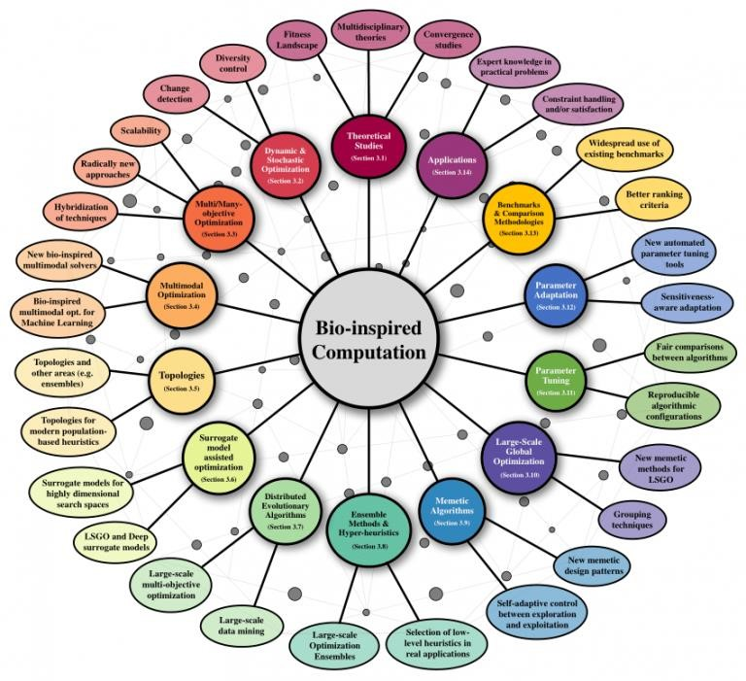

**Figure 1(1)**

## The No Free Lunch Theorems and What They Mean

(2)It claims that the NFL theorems establish the fact that no search method can be consistently superior to others over all possible types of problems. This proposition therefore echoes with the underlying requirement to devise or choose methods as per particular problem features. Essentially, instead of an across-the-board workable method, the NFL theorems point towards a more customized approach wherein the selection of method shall fall victim to the specific problem in question. This understanding is important for researchers and practitioners who want to create algorithms that can successfully use the specific details of the problems they are trying to solve.

## Particle Swarm Optimization: Advantages and Challenges

(3)Among these variational techniques, PSO has attracted considerable attention because it can mimic social behaviour in the search process involving complex spaces. PSO is inspired by the collective movement of birds flying or fish swimming, where each "particle" in the algorithm resets its position about its previous experience and the experience of the other particles within its neighbourhood. Despite its practical success, the theoretical foundations of PSO are not fully understood, posing challenges to its further development.

Older versions of PSO are still afflicted by requirements to bind the maximum velocity of the particles to retain control over where in the search space they will fly. This bound is indicative of a deeper design issue with the underlying algorithm, with consequences for its performance in certain applications. Reflection on how particles have been modelled both in discrete and continuous time has yielded a five-dimensional model that better captures the behaviour of PSO. This advanced model introduces special numbers that help the algorithm work better and faster, showing it may improve PSO's ability to find the best answers for common test problems.

## Metaheuristic Algorithms: The Need for Mathematical Analysis

Besides PSO, (4) the general class of metaheuristic algorithms has become extremely popular in modern optimization practices. In principle, metaheuristics constitute algorithms that obtain nearoptimal solutions to optimization problems, especially those problems that are beyond the scope of conventional methods. However, at the level of mathematical analysis, there is a large gap regarding most of these algorithms. Convergence and efficiency analyses, fundamental to understanding and enhancing the performance of optimization algorithms, have mostly remained unsolved for many metaheuristic approaches.

Particularly, the lack of powerful mathematical techniques to study metaheuristics poses some problems to researchers and users. Filling this gap is important for improving the field in that it would help come up with better and faster algorithms. What the writers of the document emphasize is the need for a method that can study metaheuristics based on their convergence and efficiency. This can be useful in supporting research and new ideas on this subject in the future.

## Real-World Uses: Predicting Protein Structure

(5)Optimization algorithms today find a great number of applications beyond the realm of purely theoretical research. This is, for instance, quite well attested by computational biology. The most challenging task within the latter area is arguably the so-called PSP: prediction of the three-dimensional structure of proteins by their amino acid sequences. This problem is dauntingly complex in that it presumes sophisticated algorithms capable of navigating truly enormous and intricate search spaces in search of the most likely structures of proteins.

The intrinsic link between optimization techniques and biological problems such as PSP underlines the need to devise robust algorithms that can adapt to the requirements of applied fields. Optimization algorithms can resolve practical problems, demonstrating the high utility value they can get in diverse fields if they are developed with a clear vision of concrete problems specific to certain challenges.

**Paper 1: Kennedy, J., & Eberhart, R. (1995) - Particle Swarm Optimization**

* **Introduction to PSO:**  
  This groundbreaking paper introduces Particle Swarm Optimization (PSO), a new optimization method based on the social behavior of birds flocking or fish schooling. The idea was to mimic how individual animals follow their neighbors to find resources or avoid danger.
* **Applications:**  
  PSO was proposed as a general-purpose optimization algorithm for solving problems in fields like engineering and computer science, especially those that involve complex, nonlinear search spaces.
* **Contribution to the Field:**  
  The key contribution of this paper is the creation of a simple and flexible optimization tool that requires minimal tuning compared to other algorithms like Genetic Algorithms (GA). It laid the foundation for further research in the field.
* **Working of PSO:**  
  Each particle in the swarm represents a possible solution and updates its position by considering its own best position and the best positions found by the entire swarm. This process repeats until an optimal solution is found.

### **Paper 2. Eberhart, R. C., & Shi, Y. (2001) - Evolution of PSO and Its Applications**

* **Overview of Developments:**  
  This paper reviews how PSO has evolved since its initial creation. Key improvements, such as the introduction of inertia weight, help the algorithm better balance exploration (searching broadly) and exploitation (focusing on the best solutions found).
* **Use in Real-World Problems:**  
  PSO has been successfully applied to various domains like power system load management, robot navigation, and neural network training. The authors also highlight new uses of PSO in handling dynamic systems that change over time.
* **Important Insights:**  
  The paper highlights the importance of inertia weight in controlling the velocity of particles and preventing premature convergence (getting stuck in suboptimal solutions too early). This improvement helps PSO perform better than other algorithms in many cases.
* **PSO’s Practical Use:**  
  The practical application of PSO in engineering problems demonstrates its capability to efficiently solve high-dimensional problems, making it popular in industrial and scientific optimization tasks​(PSO EBERHT SHI).
* **Paper 3. Robinson, J., & Rahmat-Samii, Y. (2004) - *PSO* in Electromagnetics and Antenna Design**
* **Focus of the Paper:**  
  This paper shows how PSO can be applied specifically to electromagnetic problems, particularly in the design and optimization of antennas. It introduces PSO as an alternative to traditional methods like Genetic Algorithms for these tasks.
* **Real-World Use in Antennas:**  
  PSO was used to optimize parameters such as the placement of elements in an antenna array to improve signal strength and reduce interference. It also helped in finding better designs in a shorter time compared to other techniques.
* **Noteworthy Achievements:**  
  The paper gained significant attention because it proved that PSO could be successfully adapted for engineering fields like electromagnetics, offering a faster and more accurate solution than traditional optimization methods.
* **Technical Approach:**  
  The authors developed a version of PSO (UCLA-PSO) fine-tuned for antenna design. They carefully adjusted the velocity and position of particles to match the engineering requirements, demonstrating the flexibility of PSO​(OPT SAMII 2004).
* **Paper 4. Shi, Y., & Eberhart, R. (1998) - Inertia Weight: Improving the Efficiency of PSO**
* **Improvement in PSO:**  
   This paper introduces an important enhancement to PSO: the inertia weight. This addition helps control how much a particle's velocity is influenced by its previous velocity, balancing the search between exploring new areas and exploiting known solutions.
* **Advantage of Inertia Weight:**  
  With inertia weight, PSO becomes more efficient, particularly in large, complex search spaces. It prevents particles from moving too quickly toward local optima, which could lead to premature convergence.
* **Why It Matters:**  
  The inertia weight modification made PSO more competitive with other optimization algorithms, especially for complex problems that require both global and local searching.
* **How It Works:**  
  By slowing down the particles as they approach better solutions, inertia weight allows for a more thorough exploration of the search space, helping PSO find more accurate solutions over time​(PSO EBERHT SHI).

**Paper 5. Jin, N., & Rahmat-Samii, Y. (2007) - *PSO* for Multi-Objective Antenna Design**

* **Introduction to Multi-Objective Optimization:**  
  This paper explores how PSO can be used to handle complex antenna design problems that have multiple objectives, such as minimizing interference while maximizing signal strength. It highlights PSO’s ability to solve multi-objective problems effectively.
* **Use in Antenna Arrays:**  
  PSO was applied to optimize both non-uniform and thinned antenna arrays, which are used to reduce the number of antenna elements while still achieving high performance. It helped improve the design by finding the best configuration of elements.
* **Impact and Innovation:**  
  The key innovation in this paper is showing how PSO can be adapted for multi-objective optimization, allowing engineers to balance multiple factors like sidelobe reduction and signal clarity.
* **Methodology:**  
  The authors used both real-number and binary PSO to optimize different aspects of antenna design. They also applied multi-objective PSO (MOPSO) to find the best trade-off between competing objectives like beamwidth and sidelobe levels​(OPT NJIN 2007....).
* **CHAPTER** 3 : **Strategic Analysis and Problem Definition**

**3.1 SWOT Analysis**

* **Strengths:** PSO is simple to implement, requires few parameters, and efficiently handles large, complex problems. Its ability to perform well across various domains makes it a versatile tool.
* **Weaknesses:** PSO is susceptible to premature convergence, where particles may get trapped in local optima, especially in highly nonlinear or large search spaces.
* **Opportunities:** The technique’s adaptability presents opportunities for use in multi-objective optimization problems, especially in fields like electromagnetics and control systems.
* **Threats:** Competing optimization algorithms, such as Genetic Algorithms and Differential Evolution, may offer better solutions for certain problem sets, potentially limiting PSO's applicability without further refinement​(OPT SAMII 2004)​(OPT NJIN 2007....).

**3.2 Project Plan - GANTT Chart**

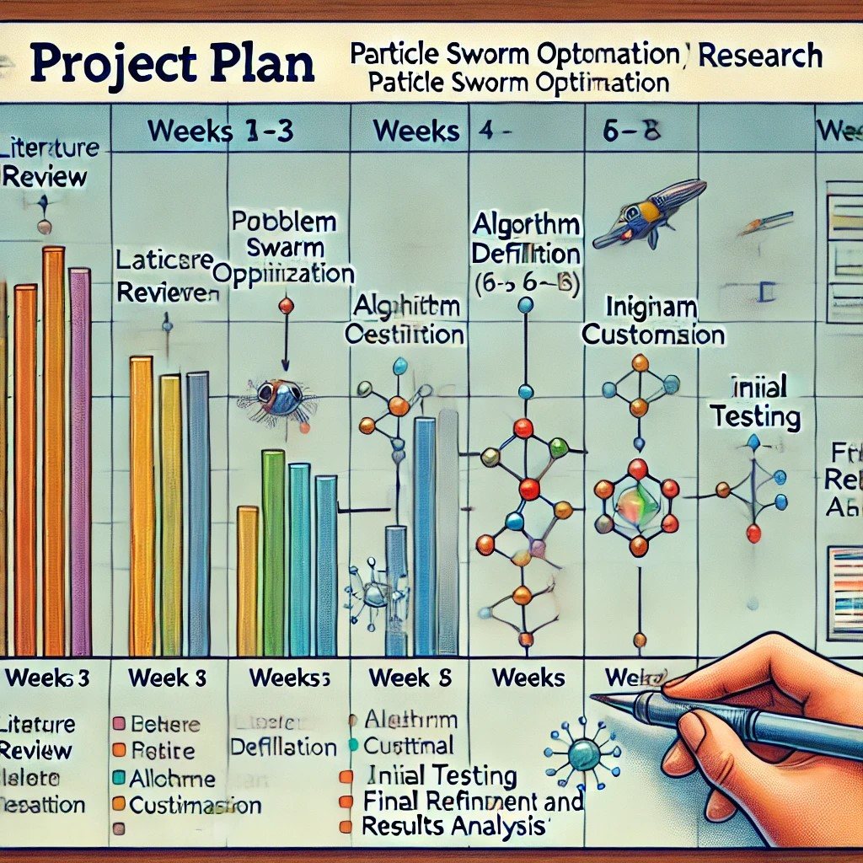

A potential Gantt chart for a PSO-related project might include the following phases:

* Weeks 1-3: Literature review and problem definition
* Weeks 4-6: Algorithm customization and parameter selection
* Weeks 7-9: Initial testing and evaluation of PSO on benchmark problems
* Weeks 10-12: Final refinement, validation, and performance analysis

**3.3 Refinement of problem statement**

As PSO has been adapted for various fields, the problem statement will be refined to address specific shortcomings, such as the need for better convergence in high-dimensional spaces. Techniques such as introducing dynamic inertia weights or hybrid optimization methods could help overcome these issues and improve solution quality​(PSO EBERHT SHI)​(OPT NJIN 2007....).

* **CHAPTER 4** : **Methodology**

The methodology behind Particle Swarm Optimization (PSO) revolves around simulating the natural behavior of swarms, such as birds or fish, that work together to find optimal solutions. In PSO, a collection of particles (possible solutions) moves through a search space to find the best answer. Each particle adjusts its position based on two key pieces of information: its personal best solution and the best-known solution found by the entire swarm.

The particles' positions are updated using velocity, which depends on personal experience (the best solution a particle has found) and social influence (the global best found by the swarm). This process continues iteratively, with particles converging toward the best solution over time.

Key variations in the methodology of PSO include:

* **Inertia Weight:** This parameter controls how much of the particle's previous velocity is carried over to the next step. A higher inertia weight encourages global exploration of the search space, while a lower inertia weight focuses on local refinement of known good solutions. This adjustment helps balance between searching widely and refining the best solutions.
* **Constriction Factor:** Another refinement, the constriction factor is used to ensure that the particles converge steadily towards the optimal solution rather than moving too far in one step, preventing them from overshooting promising areas of the search space.
* **Hybrid and Multi-Objective Approaches:** In more advanced versions of PSO, such as those used for multi-objective optimization, particles seek to balance competing goals (e.g., minimizing cost while maximizing performance). These versions often use techniques like the Pareto front to evaluate trade-offs between different objectives, ensuring the best possible solution for multiple criteria.

#### **4.1 Description of the approach**

The approach involves implementing the PSO algorithm to explore the search space, adjusting particle positions based on personal and global bests, and using velocity updates to iteratively improve the swarm's collective solution. The method has been adapted for both real-number and binary search spaces​(PSO EBERHT SHI)​(OPT NJIN 2007....).

#### **4.2 Tools and techniques utilized**

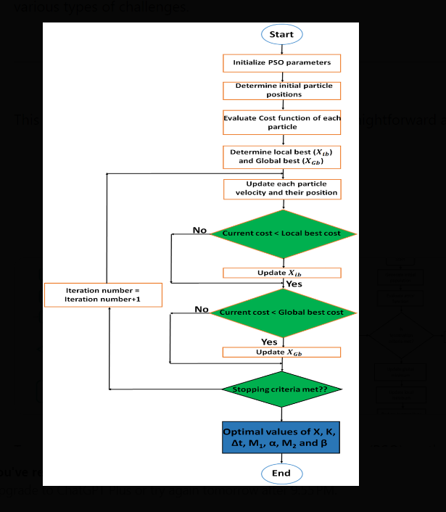

#### **4.3 Design considerations**

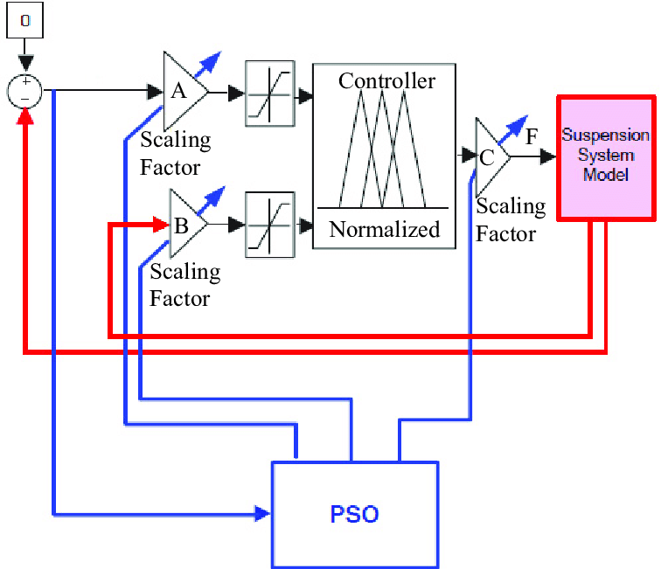

* **CHAPTER 5: Implementation**

**5.1 Description of how the project was executed**

The PSO algorithm was implemented by initializing a population of particles with random positions and velocities. The particles’ fitness values were evaluated at each iteration, and their velocities were updated based on their best-known positions and the global best solution. Various engineering problems, such as antenna design, were used to test the effectiveness of the implementation​(OPT SAMII 2004)​(OPT NJIN 2007....).

**5.2 Challenges faced and solutions implemented**

Key challenges included preventing premature convergence, handling multi-objective optimization, and managing the trade-off between exploration (global search) and exploitation (local search). Solutions included modifying inertia weights dynamically, using constriction factors, and applying hybrid algorithms to improve overall performance​(OPT NJIN 2007....).

* **CHAPTER 6: Results**

**6.1 Outcomes**

The PSO implementation yielded effective solutions for complex optimization problems. In antenna design, for example, PSO successfully optimized the position and number of elements in a nonuniform array, leading to a reduced sidelobe level and enhanced radiation pattern​(OPT NJIN 2007....).

**6.2 Interpretation of results**

Results indicate that PSO is highly effective at exploring large search spaces and finding near-optimal solutions for complex problems. However, the algorithm's performance is highly dependent on the proper tuning of parameters like inertia weight and population size​(OPT SAMII 2004)​(OPT NJIN 2007....).

**6.3 Comparison with existing literature or technologies**

Compared to other evolutionary algorithms like Genetic Algorithms, PSO is generally faster and requires fewer evaluations to reach similar or better-quality solutions. However, in certain highly nonlinear problems, PSO may require additional modifications, such as hybrid approaches, to match or exceed the performance of other optimization techniques​(PSO EBERHT SHI)​(OPT SAMII 2004)

**CHAPTER 7: Conclusion**

Particle Swarm Optimization (PSO) is a versatile and effective optimization method for various engineering challenges. Its straightforward nature allows it to navigate and exploit complex search spaces efficiently. PSO is particularly valuable in antenna design, neural network training, and power system control applications. Looking ahead, the research could aim to enhance PSO's capabilities for solving multi-objective problems and explore its integration with other optimization techniques to tackle even more complex issues.

**CHAPTER 8: Future Work**

**Research and Development Suggestions**

* **Hybrid PSO Approaches**: Future studies could investigate combining PSO with other optimization methods like Genetic Algorithms or Differential Evolution. This could enhance solution accuracy and speed up convergence.
* **Adaptive Mechanisms**: Further refinement of adaptive strategies for controlling inertia weight and velocity could help prevent premature convergence.
* **Emerging Applications**: Applying PSO to new areas, such as quantum computing and advanced neural networks, presents exciting opportunities for future exploration.

**Potential Improvements**

* **Multi-objective Optimization**: Improving PSO's ability to handle multiple objectives could involve advanced techniques for managing the Pareto front.
* **Real-time and Distributed Systems**: Adapting PSO for use in real-time dynamic systems and distributed computing environments could increase its scalability and effectiveness.

**CHAPTER 9** : **References:**

1. [Bio-inspired computation: Where we stand and what's next Javier Del Ser](https://www.sciencedirect.com/science/article/pii/S2210650218)
2. [The No Free Lunch and Problem Description Length C. Schumacher M. D. Vose and L. D. Whitley](https://scholar.google.com/scholar_lookup?title=The%20no%20free%20lunch%20and%20problem%20description%20length&author=C.%20Schumacher&publication_year=2001&pages=565-570)
3. [The particle swarm-explosion, stability, and convergence in a multidimensional complex space Clerc, Maurice , Kennedy, James](https://www.scopus.com/record/display.uri?eid=2-s2.0-0036464756&origin=inward)
4. [Metaheuristic Optimization: Algorithm Analysis and Open Problems Conference paper](https://link.springer.com/chapter/10.1007/978-3-642-20662-7_2)
5. [Selection of appropriate metaheuristic algorithms for protein structure prediction in AB off-lattice model: a perspective from fitness landscape analysis Nanda Dulal Jana, Jaya Sil, Swagatam](https://www.sciencedirect.com/science/article/pii/S0020025517300889)

[Das](https://www.sciencedirect.com/science/article/pii/S0020025517300889)